**TROUBLESHOOTING:**

**GETTING A QUOTE, PLACING AN ORDER AND MAKING A PAYMENT TO AN INVOICE**

1. After you request a quote from 25 and Gold Creative Studio, you will receive an email Quote from us. The email will look like this:

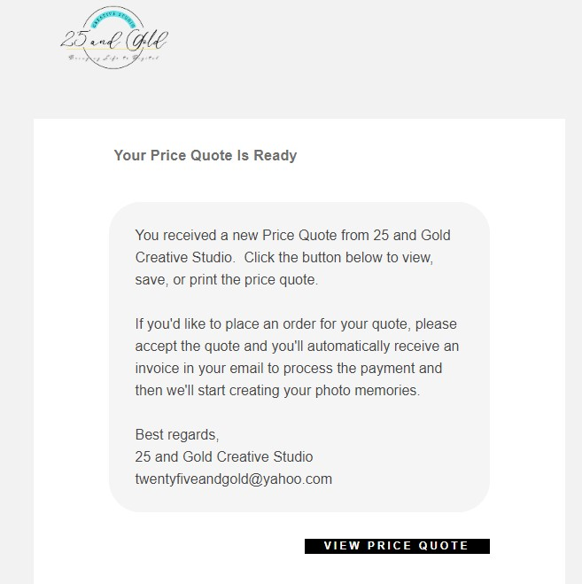

Click “**View Price Quote**”

1. After you click “**View Price Quote**”, you will be taken to this screen, where you will be able to view your personalized Quote from us.

If you would like to go ahead with your order, just click the “**Accept**” button located at the top right hand corner of the quote.

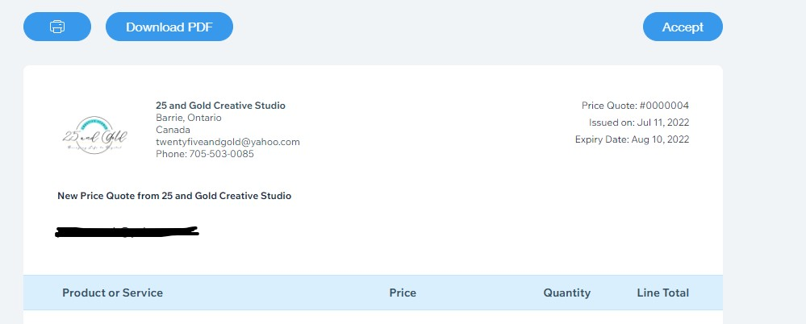

1. After you select “**Accept**”, you’ll receive a confirmation. Now check your email Inbox.

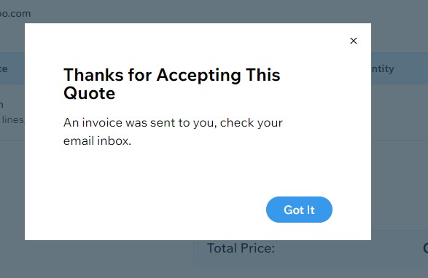

4. Once you check your Email inbox, you should have automatically received an email from us with your Invoice. To view the invoice, click on the “**View Invoice**” button.

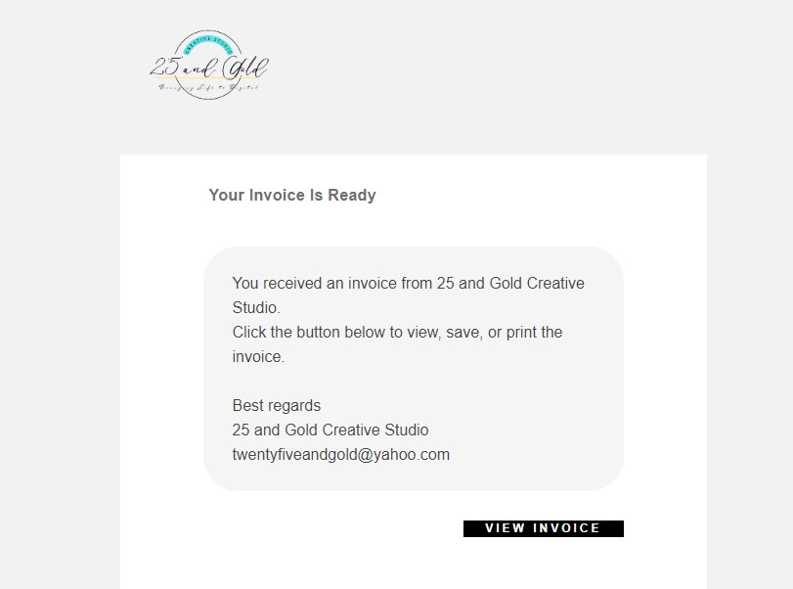

Click “**View Invoice**” to pay for your order.

5. After you select “**View Invoice**”, you’ll then be able to select “**Pay Invoice**”. This is the “**Pay Invoice**” button. You’ll click this button on the invoice you received:

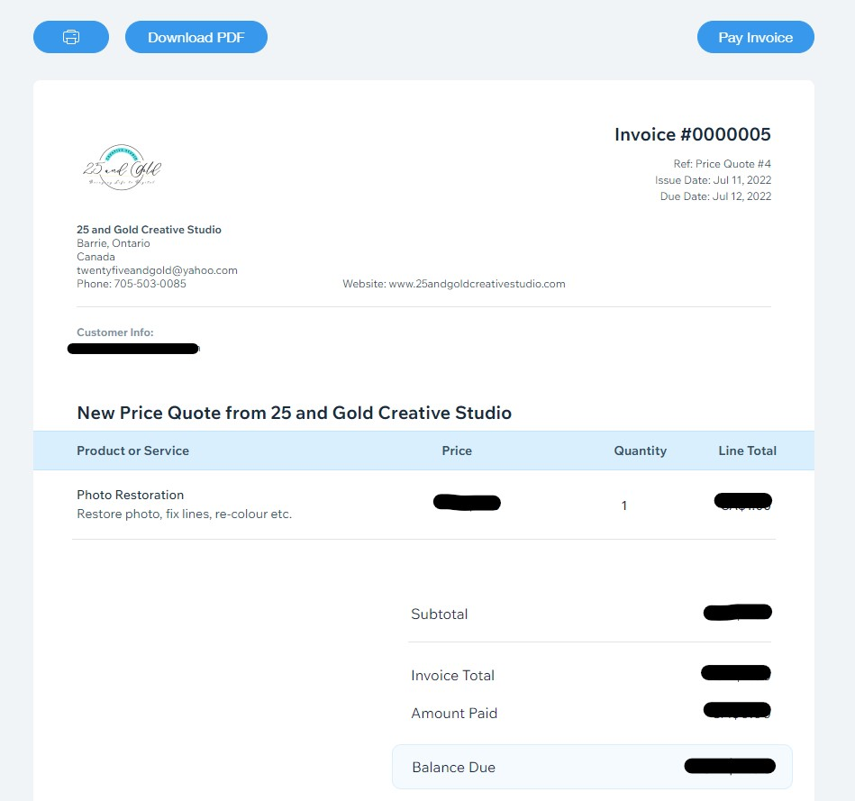

6. After you press “**Pay Invoice**”, you’ll be directed to input your payment details, such as your Debit or Credit Card information or a prompt to login your Paypal account for payment. Choose how you’d like to pay and proceed in entering in your payment information.

7. Once you submit payment, you’ll receive a confirmation screen, confirming your order is now complete!! You’ll receive an email from us confirming we’ve received your order. You will receive your order within 2 weeks.

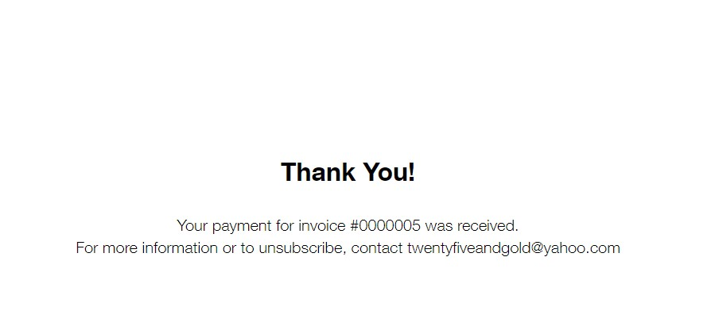

8. Now just wait until your restorations are complete and keep an eye on your email inbox for our email. Check your junk folder, just in case.